Chapter 6, Solution 24.

Assume that all the capacitors were initially uncharged and that the 90 volt source starts at zero and gradually increases to 90 volts. What are the final voltages across each capacitor and the energy stored in each capacitor.

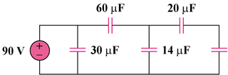
80 µF

Figure 6.58
For Prob. 6.24.

Solution

20μF is series with 80μF = 20x80/(100) = 16μF

14μF is parallel with 16μF = 30μF
v_{30μF} = 90V
v_{60μF} = 30V
v_{14μF} = 60V
v_{20μF} = 48V
v_{80μF} = 60 - 48 = 12V

- Since w =
w_{30μF} = 1/2 x 30 x 10⁻⁶ x 8100 = 121.5mJ
w_{60μF} = 1/2 x 60 x 10⁻⁶ x 900 = 27mJ
w_{14μF} = 1/2 x 14 x 10⁻⁶ x 3600 = 25.2mJ
w_{20μF} = 1/2 x 20 x 10⁻⁶ x (48)² = 23.04mJ
w_{80μF} = 1/2 x 80 x 10⁻⁶ x 144 = 5.76mJ

